主题：老年人口

题型：线图

The graph below shows the proportion of the population aged 65 and over between 1940 and 2040 in three different countries

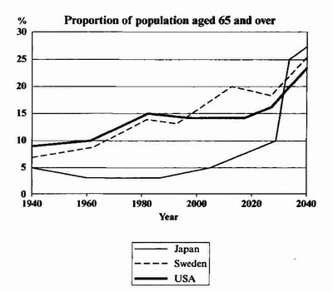

满分范文：

The line graph compares the percentage of people aged 65 or more in three countries over a period of 100 years.

It is clear that the proportion of elderly people increases in each country between 1940 and 2040. Japan is expected to see the most dramatic changes in its elderly population.

In 1940, around 9% of Americans were aged 65 or over, compared to about 7% of Swedish people and 5% of Japanese people. The proportions of elderly people in the USA and Sweden rose gradually over the next 50 years, reaching just under 15% in 1990. By contrast, the figures for Japan remained below 5% until the early 2000s.

Looking into the future, a sudden increase in the percentage of elderly people is predicted for Japan, with a jump of over 15% in just 10 years from 2030 to 2040. By 2040, it is thought that around 27% of the Japanese population will be 65 years old or more, while the figures for Sweden and the USA will be slightly lower, at about 25% and 23% respectively.